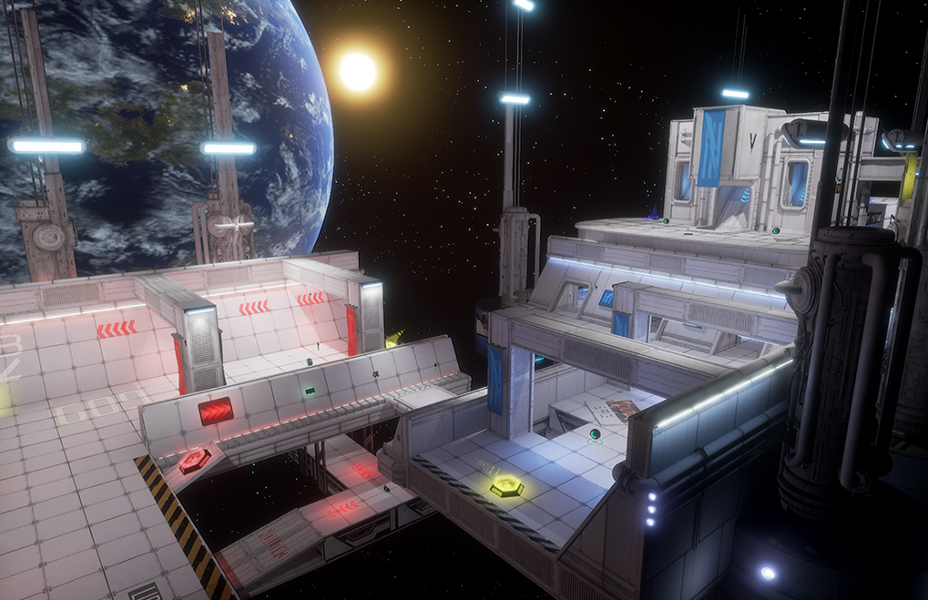

**Level Design Document –UT4 Multiplayer Level**

|  |  |
| --- | --- |
| Designer | William Bracho Blok |
| Level Name | Egocentric Empanadas |
| Due Date | December 8, 2017 |

|  |  |  |
| --- | --- | --- |
| Document Revisions | | |
| Date | **Description** | **Initials** |
| 11/17/2017 | Transfer information from the overview document to this document | WBB |
| 11/19/2017 | Complete all required sections of the document | WBB |
| 11/20/2017 | Refine content, update diagrams and image references | WBB |
| 12/08/17 | Update aesthetics section and diagrams | WBB |

Contents

1. Overview 4

Map Overview 4

Summary 7

Hooks 7

Development Schedule 7

2. Gameplay 8

Flag Area 8

Detailed Area Map 8

Area Description 8

Requirements 8

Outer Base 9

Detailed Area Map 9

Area Description 9

Requirements 9

Midground 10

Detailed Area Map 10

Area Description 11

Requirements 12

Lower Ground 13

Detailed Area Map 13

Area Description 14

Requirements 14

3. Aesthetics 14

General Thematic Elements 14

Flag Area 14

Lighting 14

Visual References 15

Outer Base 16

Lighting 16

Visual References 16

Midground 17

Lighting 17

Visual References 17

Lower Ground 18

Lighting 18

Visual References 18

4. References 19

# Overview

## Map Overview

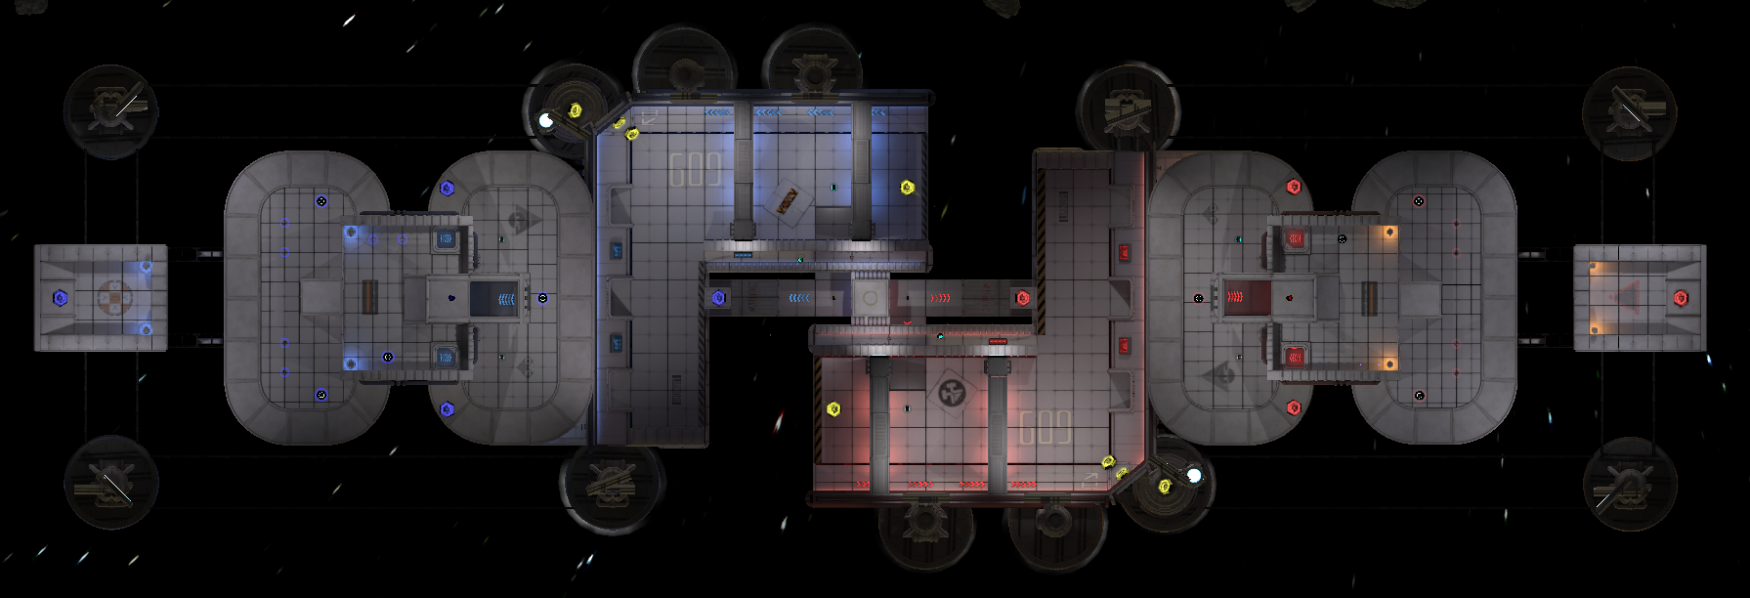

**Figure 1**: top down view of the level in level editor

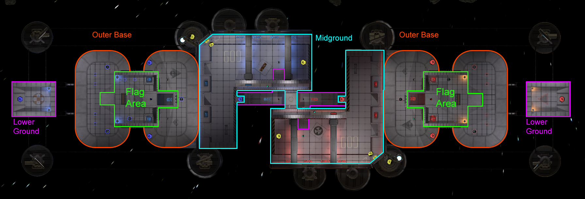

**Figure 2**: top down view of the level with areas labeled. The midground and lower ground are partially covered with the flag area and outer base area

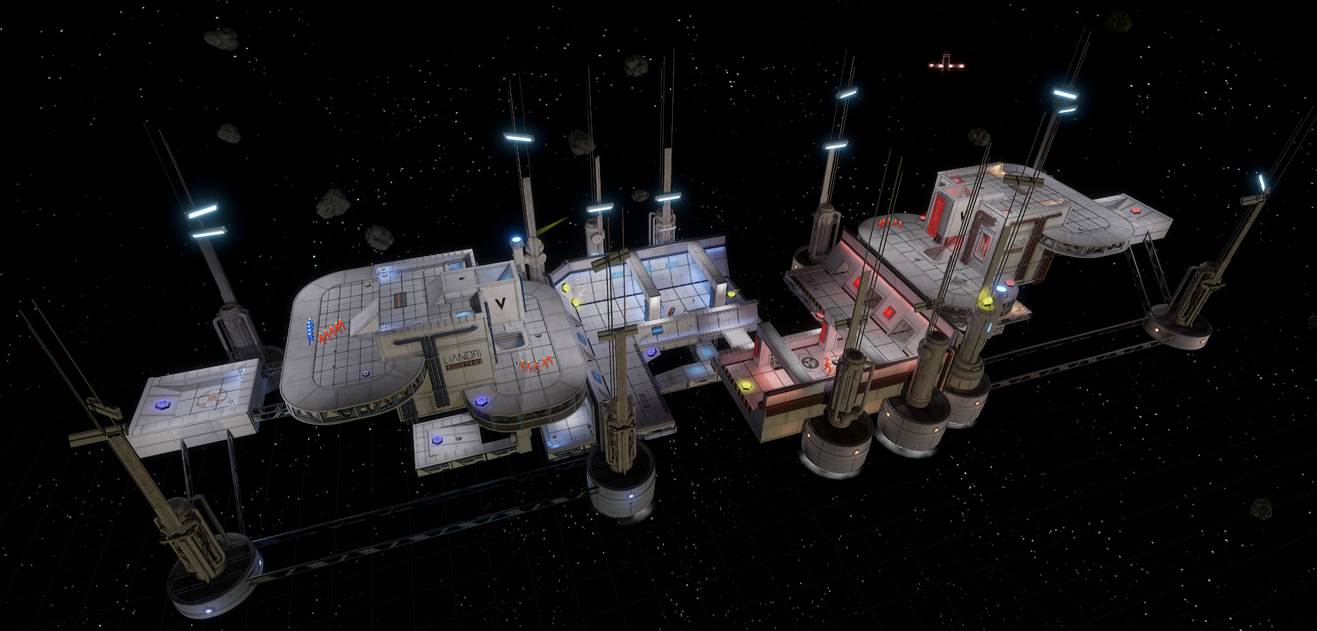

**Figure 3**: in-editor perspective view of the whole level

## Summary

Egocentric Empanadas is a Capture the Flag (CTF) multiplayer map where two opposing teams fight each other to capture the other team’s flag and return it to their base to score points. This is a map developed for Unreal Tournament 4 with a focus on fast-pace gameplay, and it is designed for 8 players (4 players per team).

This is an open space combat arena resembling a space station under construction orbiting in outer space. Its theme and design is inspired from maps such as The Longest Yard deathmatch map from Quake III[1] and Plunge from Unreal Tournament 2004[2]. Its overall shape is lineal so that the bases are at opposite ends of the map and are directly facing each other. Each area of the map has varying elevation so that the bases and the flag area are set at the highest altitude, making them predominantly visible in the level, and the middle and lower ground are set at the lowest altitude. This map also provides several jump pads with long trajectories for players to quickly fly around the map like in Rise of The Triad[3] and engage in mid-air combat.

## Hooks

* It is an open space map set in outer space.
* It makes extensive use of jump pads, some of which players can use to quickly fly around the level and land directly into the enemy’s flag.
* It encourages very fast-paced gameplay using jump/boost pads.
* It has chutes for players to slide down from the flag area to the outer flag area and to the midground.
* The map title

## Development Schedule

|  |  |  |
| --- | --- | --- |
| Date | Milestone | Condition of Satisfaction |
| 19-Oct-17 | Level concept and sketch | Have a detailed plan for creating the CTF map |
| 27-Oct-17 | First pass gameplay | Have a fully playable CTF level created with BSP geometry, and implement all the planned features |
| 9-Nov-17 | Complete gameplay | Refine and finalize the map layout and items based on feedback |
| 1-Dec-17 | First pass aesthetics | Replace all BSP brushes with static meshes and have final lighting planned out |
| 8-Dec-17 | Final aesthetics | Finalize all level aesthetics |

# Gameplay

## Flag Area

### Detailed Area Map

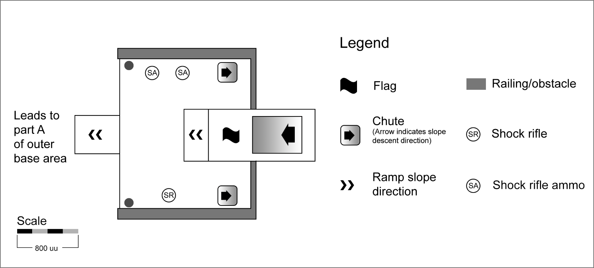

**Figure 4**: top down diagram of the flag area. This diagram corresponds to the left flag area from **figure 2**. The right flag area is mirrored (rotated) around the center of the level.

### Area Description

The flag area, as its name implies, contains the team’s flag. It provides a shock rifle with ammunition and a vantage point to attack enemies at their base and nearby. Players can also attack from this area as a last resort to stop enemies from reaching their base. To avoid overpowering this area, a shock rifle was provided instead of a sniper rifle as it is much harder to snipe enemies down from afar with the shock rifle.

This area can also be used to guard the flag and stop enemies coming from the outer base area. Players could stay crouched between the flag platform and one of the chute entrances to hide and attack incoming enemies by surprise with a short-range weapon such as the flak cannon; however, this area does not provide the flak cannon or any other additional resource to discourage players from staying in the area for too long.

The flag area also features three covered slides or chutes: two side chutes that take players down to part B of the outer area, and one larger central chute that takes players down to the middle ground. Players can use the side chutes to quickly get to part B of the outer area to pick up health and acquire the rocket launcher when needed. Enemies can also use them to quickly escape the base once they capture the flag.

### Requirements

This area requires no special scripted elements or additional assets.

## Outer Base

### Detailed Area Map

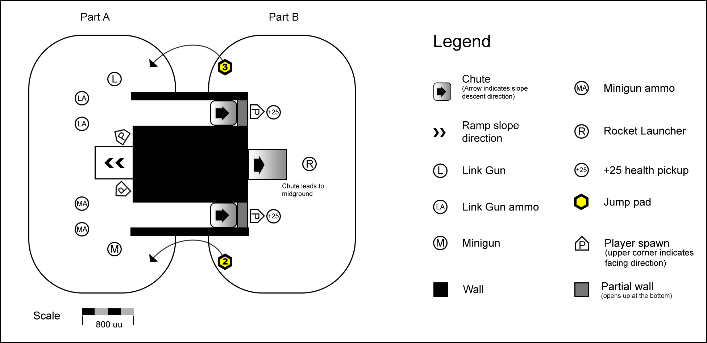

**Figure 5**: top down diagram of the outer base. This diagram corresponds to the one on the left side from **figure 2**. The right one is mirrored (rotated) around the center of the level.

### Area Description

The outer base area consists of 2 rectangular platforms (area A and area B) that surround the base and serve as a first line of defense to stop incoming enemies. Area B has a lower elevation than area A and serves as the main entrance to the base. It serves as a small combat area where players can stand to guard the base and to stop enemies coming from the middle ground. Area A has a higher altitude than area B and can be used to guard the entrance of the flag area and stop enemies coming from part D from the lower ground. Overall, this is a great area for defense players to stay and guard the base; it provides the rocket launcher, the link gun, the minigun and has two 25-health pickups so that players can constantly circulate between part A and part B of this area to replenish resources, patrol around the base, and attack incoming enemies.

### Requirements

This area requires no special scripted elements or additional assets.

## Midground

### Detailed Area Map

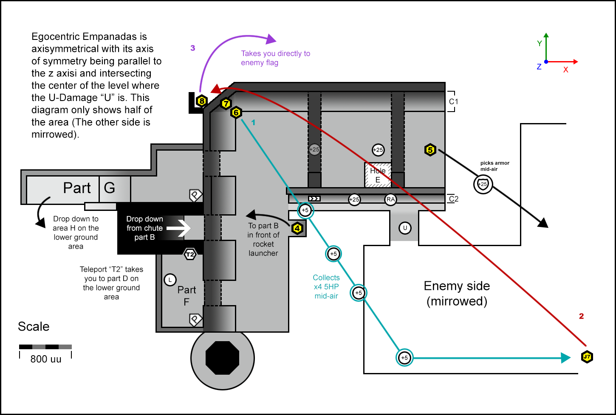

**Figure 6**: top down diagram of the midground. The enemy side is mirrored (rotated) around the U-Damage which lines up with the center of the level.

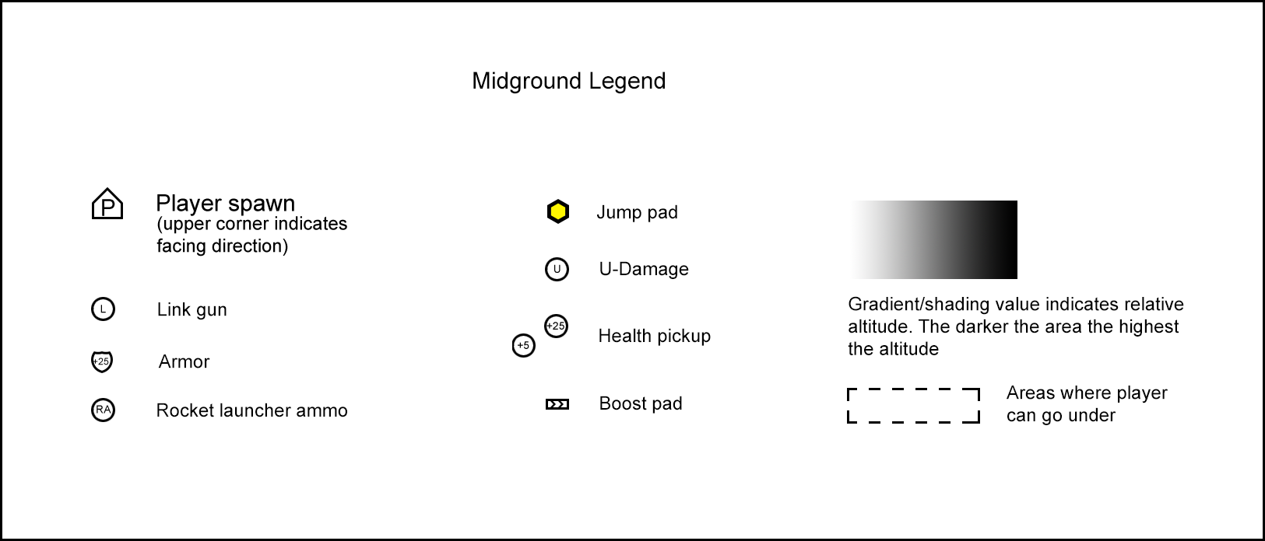

### Area Description

The mid ground consists of two L-shaped platforms situated in the middle of the map. It serves as a raceway to get into the enemy’s flag as well as a combat area where players engage in mid-range combat. The midground features high-force jump pads that players can use to move around the midground area very quickly, engage in mid-air combat, and dodge enemies on the way to reach the enemy’s base. It also features a series of arcs that adds partial coverage to the area from enemies attacking from the base. Additionally, this area provides three main routes that players can take to reach the enemy’s base: the midground route, the lower ground route, and the aerial route.

The midground route: this route is perhaps the most noticeable and straightforward route; it contains the most resources among the three main routes, but it is also the slowest route. Once players descent from their base, they can either take jump pad 5 or 6 to reach the enemy side of the midground. Then, players can enter the enemy base by taking 4 to land on area B, then taking either jump pad 2 or 3 to land on area A, and finally reaching to the enemy flag after running up the stairs. This route takes roughly 20 to 28 seconds to traverse.

*Variant 1:* a variant of this route consists on taking the boost pads located in the inner slanted walls (labeled as C2 on **figure 6**) to perform a boosted wall run and take the U-Damage. From the U-Damage spot, players can then jump to area C2 on the enemy side and run on the ledge to reach area C and take the jump pad 4 on the enemy side to reach part B of the enemy outer base area (see **figure 4**). Players could also drop down from the U-Damage spot to the lower ground and continue with the lower-ground route to reach the enemy base.

*Variant 2:* another variant of the Mid-Ground Route is that instead of taking the jump pad 4 to land on area B (enemy side), players take either one of the two alternate entrances that leads to part G or part F, both of which merge with the lower ground route at part D.

The lower-ground route: this route has fewer resources than the Mid-Ground route, but has more resources than the aerial path. Once players descent from their base, they can jump down to the lower ground from jumping off C2 or jumping down through hole E (see **figure 6**). At this point, players can take either one of the following choices to reach area D on the enemy side:

1. *Take the teleport T1 on the enemy side* to teleport directly into part D (see **figure 7**). This choice provides the fastest way to reach part D, but the player does not get to pick up the flack cannon on the way unless the player jumps back from part D to Part H.
2. *Run across area K and take the Jump pad 9 on the enemy side*, which takes players to part K and jump from jump pad 10 to reach area D.

Once players reach area D, they can take the jump pad 1, which leads to area A on the enemy outer base. From here, players can walk up the stairs to reach the enemy flag and return to their base. Overall, this route takes roughly 16 to 24 seconds to take depending on the player’s sub-route choices.

The aerial route: the aerial route is perhaps the most fun, dangerous and the quickest route to reach the enemy flag. It is also the route that contains the least amount of resources and requires players to use the ability to wall-run. Once players descent into the midground, they can take the jump pad 6 to land on C1 on the enemy side (see **figure 6**). If players perform a wall-run on C1 on the enemy side, they can then reach jump pad 7 on the enemy side, which makes the player fly across the map to land right on the jump pad 8 back on their team side. Once the player takes the jump pad 8, the player will fly back to the enemy side and land *right on top* of the enemy’s flag. This path takes approximately 12 seconds to take and is one of the most distinctive features of this map.

### Requirements

This area requires no special scripted elements or additional assets.

## Lower Ground

### Detailed Area Map

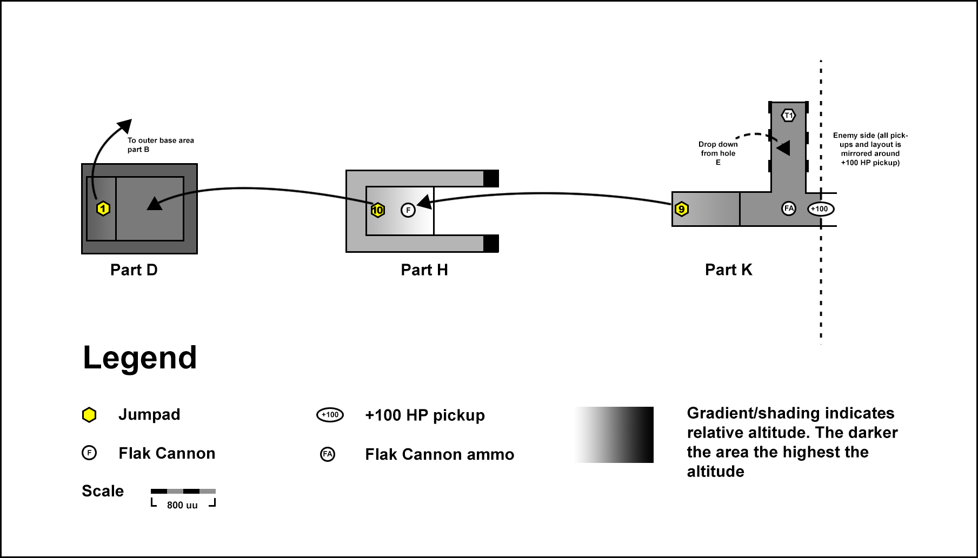

**Figure 7**: top down diagram of the lower ground. The enemy side is mirrored (rotated) around the +100 health pickup, which lines up with the center of the level.

### Area Description

The lower ground area is an extension of the midground area. It provides an alternative route for players to reach into the enemy base from below and behind and attack them by surprise. This area also serves as a detour route from the midground where players can seek cover and regain health by picking up the keg o’ health in the middle (+100 health pickup). Additionally, this area has two teleport pads that takes players back to part G on the midground (one for each side of the midground).

### Requirements

This area requires no special scripted elements or additional assets.

# Aesthetics

## General Thematic Elements

The overall look of the map resembles a down-sized sci-fi stadium floating in space. It is mostly built with metal painted in white with a few accent colors so that it contrasts with the dark galaxy background, and it is lit with elevated spot lights like a soccer stadium. The map also features a fascinating look to 2 planets and a sun, which are predominantly visible and situated on the sides of the map and serve as landmarks. The map features a space-like theme with some elements borrowed from the look of an oil refinery, so elements such as metal pipes, rails, vents, and antennas are predominant in the aesthetics of the map. The overall look of the walls and ceilings features a variety of detail elements such as pipelines, metal trims, vents, and hatches, all of which add interesting details to the structure of the level and contributes to the immersion of the player. On the other hand, the floors in general have a simpler and cleaner look; it is composed mostly of white metal panels with fewer details to make the walkable areas easy to follow.

## Flag Area

Being at the flag area gives the sensation of being at the top of the control room of a ferry as these are the highest areas of the map, except that it has no walls or ceiling. The floor of this area consists on white metal panels with a few vent panels placed on one of the borders of the area and decal.

### Lighting

Like most of the areas of the level, this area is bright and lit from above by elevated light posts situated around the perimeter of the map and with floor lamps. The overall color of the lighting is set to white with a hint of red or blue depending on which side the flag area is. This area also features some decorative lightings from the chevrons that lead to the chutes. The chevrons on the blue base are colored blue, and the chevrons from the red base are colored red.

### Visual References

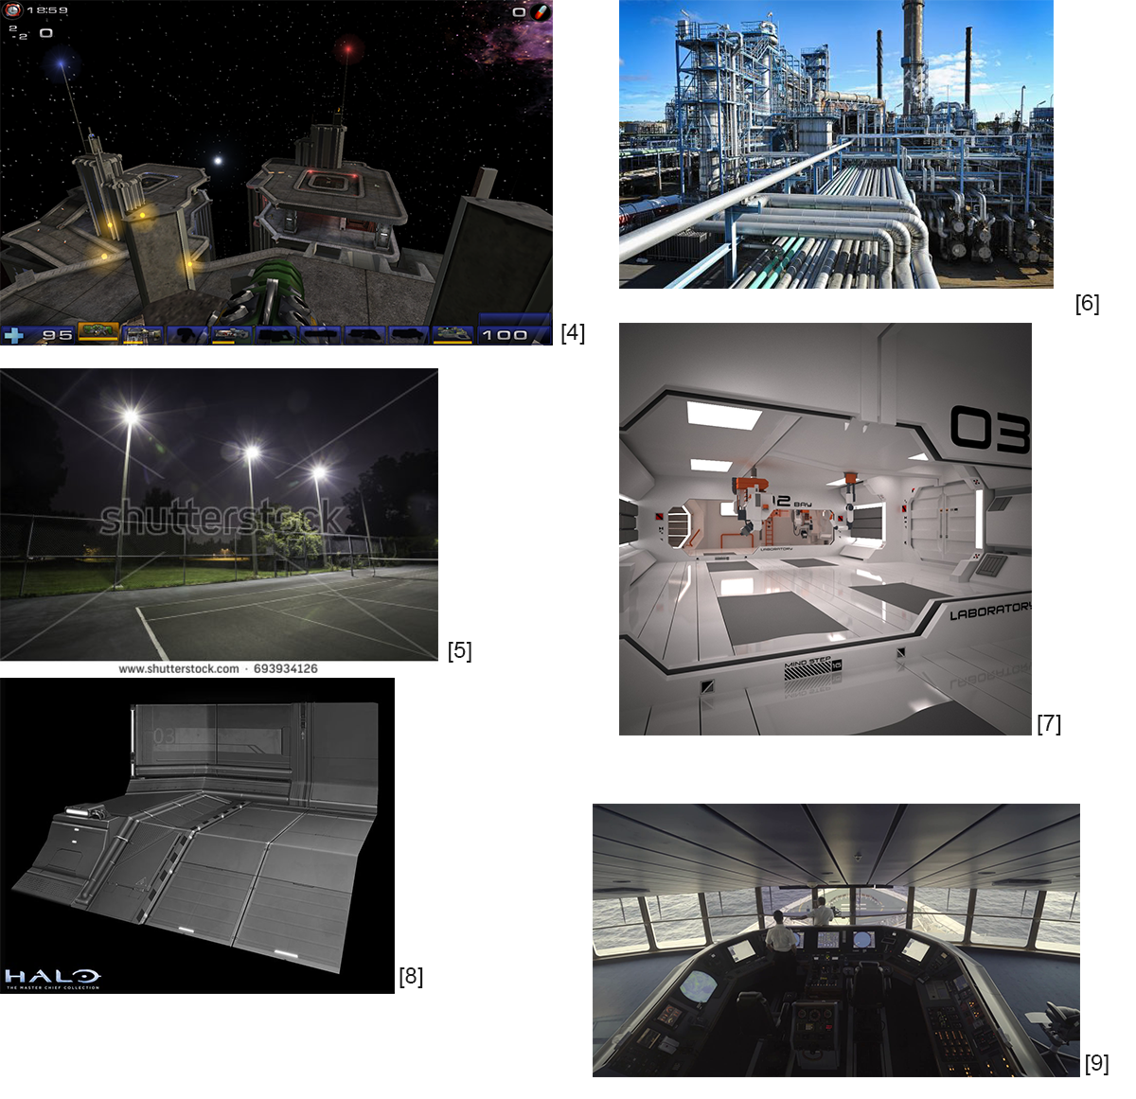

## Outer Base

This area also has a similar thematic to the flag area and most other areas of the level. It features white metal panel with few details for floors, and the walls contain a variety of elements that give them interesting details, such as pipelines, vents, and decals posted on floors and walls. Earlier in the development of this level, the platforms that composed this area had the shape of flat empanadas (see visual reference 10 for an image of empanadas). Because these platforms were surrounding the base, they were then called egocentric empanadas, which explains the whimsical name of the map. Later in the development of the map, the shape of these platforms was changed to a rectangular shape with rounded corners because the previous shape was very difficult to replicate with the provided static mesh models. However, the name Egocentric Empanada (the working title of the level at the time) was kept as it made the level more memorable.

### Lighting

Like most of the areas of the level, this area is bright and lit with white light from above by elevated light posts situated around the perimeter of the map. It also has some decorative accent lights such as the chevron lights from the central chute, the emissive lights from the jump pad, and a large wall flag which serve to orient players.

### Visual References

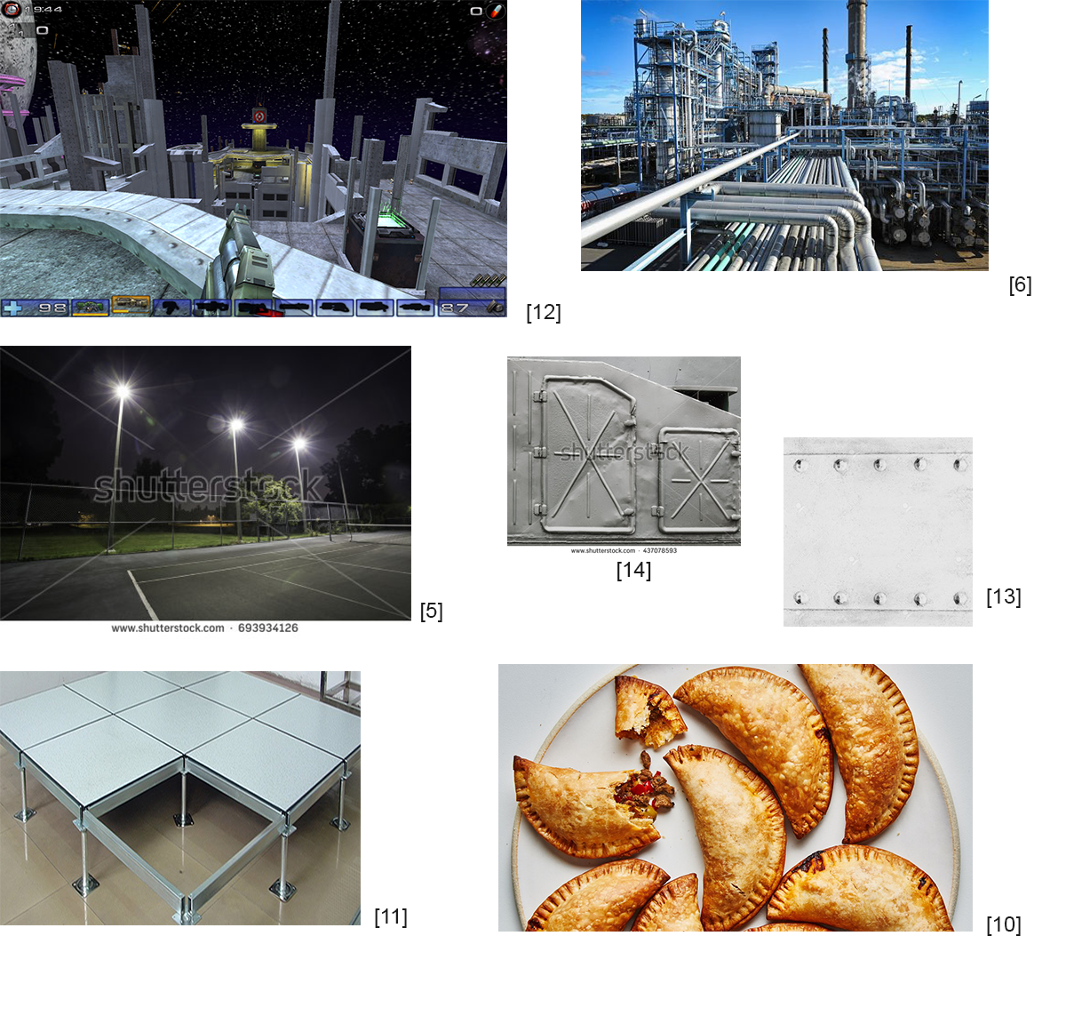

## Midground

The midground area has a similar thematic to the other areas of the level. It features white metal panel with few details for floors, and the walls contain a variety of elements that give them interesting details, such as pipelines and vents. In addition, this area has a series metal square arcs that connect the inner borders with the outer walls; these arcs give additional levels of detail and support to the overall structure of the level by forming an implied tunnel on each side of the map through which players fight and race to get to the bases.

### Lighting

Like most of the areas of the level, this area is mostly lit from above by elevated light posts situated around the perimeter of the map. It also features fluorescent ceiling lamps situated on the ceiling of midground arcs and fluorescent light bulbs embedded in the walls of the area which give a hint of red or blue depending on which side of the midground they are.

### Visual References

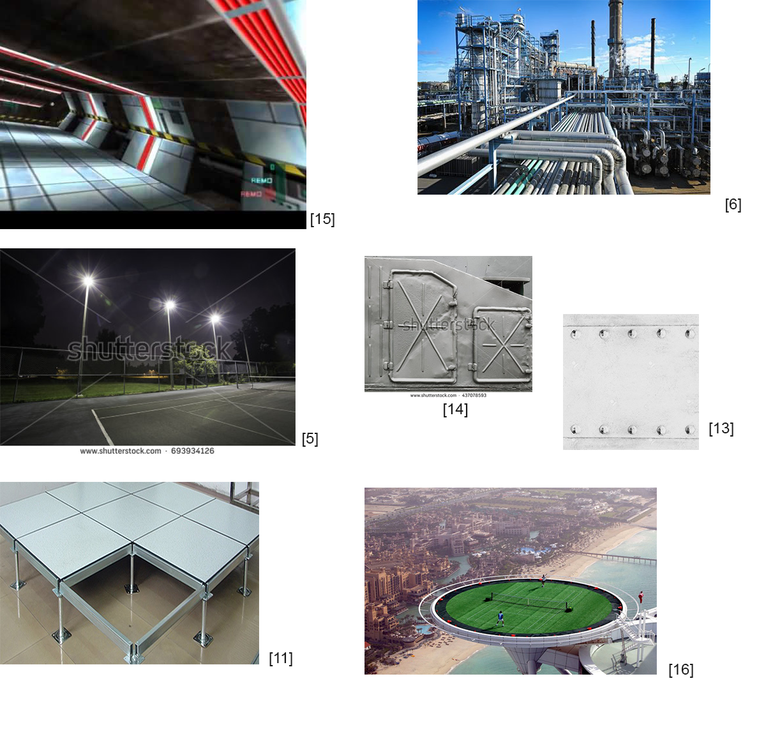

## Lower Ground

The lower area has a similar thematic to the other areas of the level. It features white metal panel with few details for floors, and the columns and other structures that attaches it to the midground contain a variety of elements that give them interesting details, such as pipelines and metal frames.

### Lighting

Unlike most of the areas of the level, this area is lit from ceiling lamps situated on the bottom face of the midground platforms. This area maintains roughly the same illumination level as the rest of the map and has some decorative accent lights such as colored chevron lights and jump pad lights which are colored either red or blue depending on which side they are in.

### Visual References

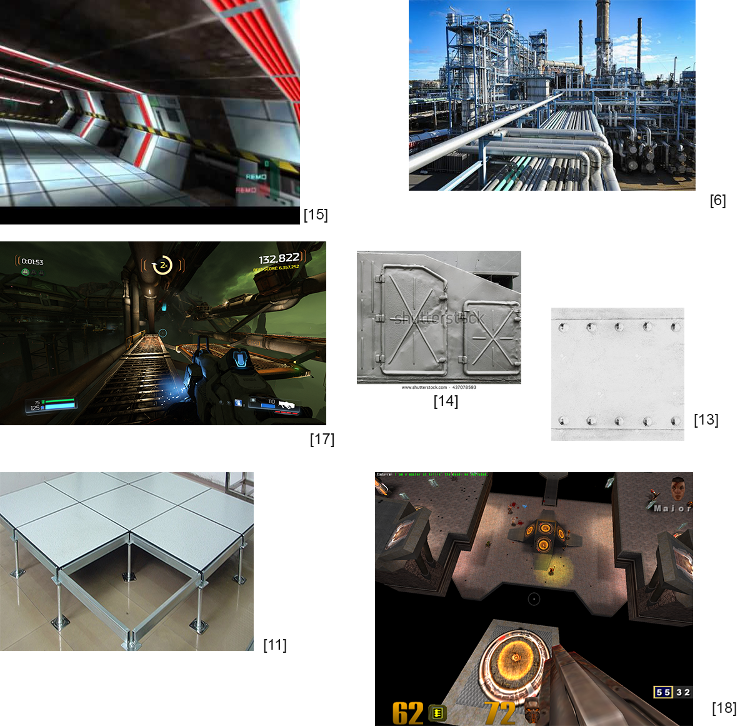

# References

[1] <https://www.google.com/url?sa=i&source=images&cd=&cad=rja&uact=8&ved=2ahUKEwiq7_GYrtPfAhUIRa0KHXBzCbQQjRx6BAgBEAU&url=https%3A%2F%2Flvlworld.com%2Freview%2FThe%2520Longest%2520Yard%2520-%2520Duel&psig=AOvVaw11sPyo7sx4-w6-B6z3Kmdt&ust=1546664979492099>

[2]

<https://www.google.com/search?q=ut+2004+plunge&rlz=1C1FGUR_enUS762US762&source=lnms&tbm=isch&sa=X&ved=0ahUKEwil7pXertPfAhVJ4qwKHRSZAs4Q_AUIDygC&biw=1903&bih=928#imgrc=qbbQNZtwur9ZTM>:

[3] Refers to both the original Rise of The Triad game (http://store.steampowered.com/app/358410/Rise_of_the_Triad_Dark_War/) and the remake version (<http://store.steampowered.com/app/217140/Rise_of_the_Triad/>)

[4] A screen capture I took while playing Unreal Tournament 2004 on the Morpheus3 deathmatch map

[5] <https://www.google.com/search?q=tennis+court+lit&rlz=1C1FGUR_enUS762US762&source=lnms&tbm=isch&sa=X&ved=0ahUKEwjblovpxsbXAhVCzFQKHYxkBiQQ_AUICigB&biw=1920&bih=925#imgrc=FAn0QsZIRQRiBM>:

[6] <https://www.google.com/search?q=oil+refinery&rlz=1C1FGUR_enUS762US762&source=lnms&tbm=isch&sa=X&ved=0ahUKEwia__7d8c3XAhUGwFQKHYWUA0gQ_AUIDCgD&biw=1920&bih=925#imgrc=b730bk-ZMtvnkM>:

[7] <https://www.google.com/search?q=white+futuristic+environment&rlz=1C1FGUR_enUS762US762&source=lnms&tbm=isch&sa=X&ved=0ahUKEwiEjPT_ycbXAhVkiVQKHbNNAQAQ_AUICigB&biw=1920&bih=925#imgrc=tou_OFLRhGneCM>

[8] <https://www.google.com/search?q=white+futuristic+environment&rlz=1C1FGUR_enUS762US762&source=lnms&tbm=isch&sa=X&ved=0ahUKEwiEjPT_ycbXAhVkiVQKHbNNAQAQ_AUICigB&biw=1920&bih=925#imgrc=wNvngJIhHcapvM>:

[9] <https://www.google.com/search?rlz=1C1FGUR_enUS762US762&biw=1920&bih=925&tbm=isch&sa=1&ei=ezITWquZOZejjwTB-pyIAQ&q=view+from+control+room+of+a+ship&oq=view+from+control+room+of+a+ship&gs_l=psy-ab.3...24120.25302.0.25470.10.8.0.0.0.0.246.766.0j2j2.4.0....0...1.1.64.psy-ab..8.0.0....0.YjGNDWP6HOY#imgrc=ysnCVf7up5xQ7M>:

[10] <https://www.google.com/search?q=empanada&rlz=1C1FGUR_enUS762US762&source=lnms&tbm=isch&sa=X&ved=0ahUKEwjMx_in-s3XAhWJrlQKHUlkAVoQ_AUICigB&biw=1920&bih=925#imgrc=yk_chMnADX3TdM>:

[11] <https://www.google.com/search?q=metal+floor+tiles&rlz=1C1FGUR_enUS762US762&source=lnms&tbm=isch&sa=X&ved=0ahUKEwjlmsCIkM7XAhUKqlQKHc9gAWkQ_AUICygC&biw=1920&bih=925#imgrc=s3ytXYU9Ak6YUM>:

[12] A screen capture I took while playing Unreal Tournament 2004 on the Plunge map

[13] <https://www.google.com/search?rlz=1C1FGUR_enUS762US762&biw=1920&bih=925&tbm=isch&sa=1&ei=VVATWrSrCMSKjwTW9Iz4BA&q=old+white+metal&oq=old+white+metal&gs_l=psy-ab.3..0l2j0i24k1l2.29480.31276.0.31364.15.9.0.6.6.0.117.773.7j2.9.0....0...1c.1.64.psy-ab..0.15.787...0i67k1.0.Xi_PsjuqzqA#imgrc=pciFFC1Ju8m3XM>:

[14]

<https://www.google.com/search?q=metal+hatch&rlz=1C1FGUR_enUS762US762&source=lnms&tbm=isch&sa=X&ved=0ahUKEwjaiuKIlM7XAhXolVQKHVKzBPMQ_AUICygC&biw=1920&bih=925#imgrc=6jYtz7o9naLhZM>:

[15] <https://www.google.com/search?q=perfect+dark+n64&rlz=1C1FGUR_enUS762US762&source=lnms&tbm=isch&sa=X&ved=0ahUKEwjY2r2Bls7XAhUFi1QKHSRzCiMQ_AUIDCgD&biw=1920&bih=925#imgrc=H3TDicPCxl3YYM>:

[16]

<https://www.google.com/search?q=tennis+court+on+top+of+skyscraper&rlz=1C1FGUR_enUS762US762&source=lnms&tbm=isch&sa=X&ved=0ahUKEwju2O_jl87XAhVhllQKHTbhBr4Q_AUICigB&biw=1920&bih=925#imgrc=lLxP2jcSg5tu7M>:

[17] A screen capture I took while playing Doom (2016) on the Argent Energy Tower level in arcade mode

[18] <https://www.google.com/search?q=quake+3+longest+yard&rlz=1C1FGUR_enUS762US762&source=lnms&tbm=isch&sa=X&ved=0ahUKEwiKutyKms7XAhVrzlQKHQT0AIMQ_AUICigB&biw=1920&bih=925#imgrc=ISMZvJlvqa8JXM>: